
Procedure 2025

ArcelorMittal Building Solutions France Procedure 1.1.1.6

SAP VARIANTS

CREATING AN SAP VARIANT

STEP 1: Go to SAP and fill in all the accounts to be listed using the arrow below:
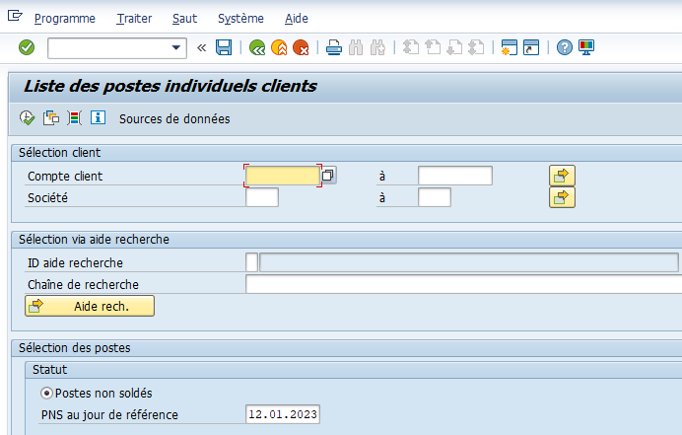

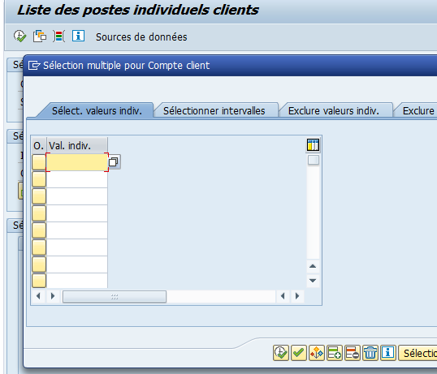

Search for the SAP code using the Sofie code

Or fill in the SAP code directly

Then validate

STEP 2: Save the variant to find it in the list

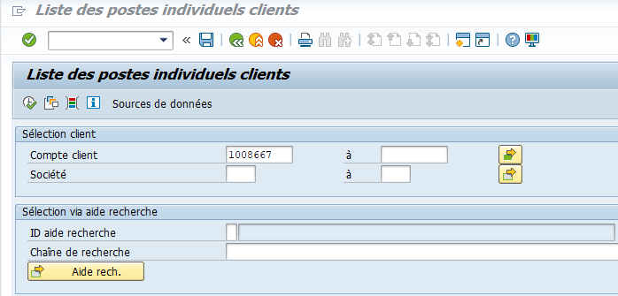

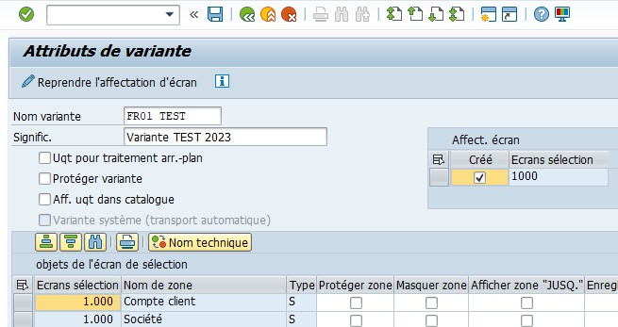

Complete only :
- Variant name = FR01 + name of group to be created (e.g. FR01 CIBETANCHE)
- Signific = Variant + name of group to be created + current year if updated (ex: Variante ORCAB 2023)

Do not change anything else, then validate by clicking again on the diskette to save it:
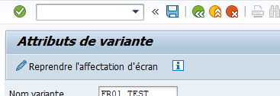

MODIFY A SAP VARIANT

STEP 1: Find the SAP variant to be modified
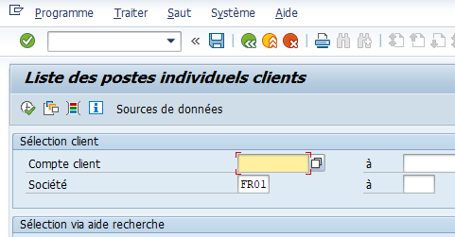

Remove the name entered in "created by" and confirm (or F8):
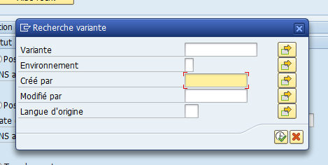

Double-click to select the variant:
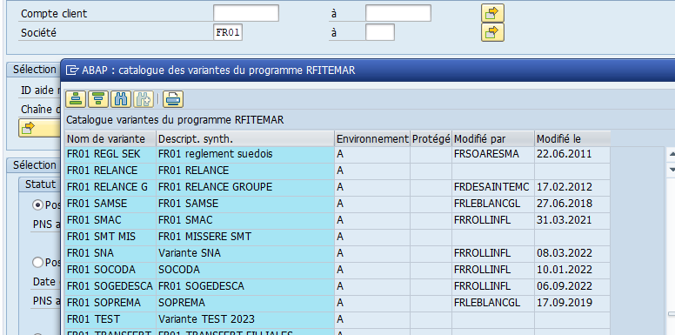

STEP 2: Modify SAP variant

Once the variant has been selected, go to the list of accounts included in the variant:
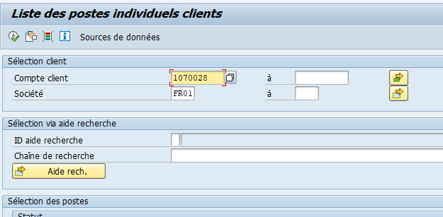

Add or delete the desired accounts, then confirm:

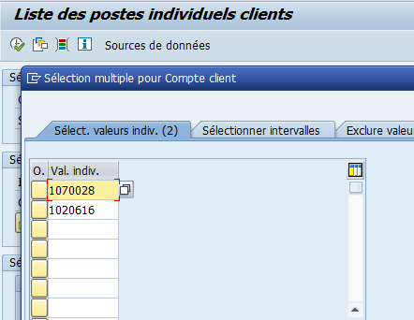

Save the changes made to the variant:
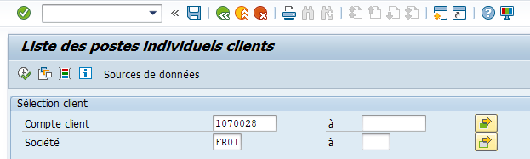

Click on the diskette to save:

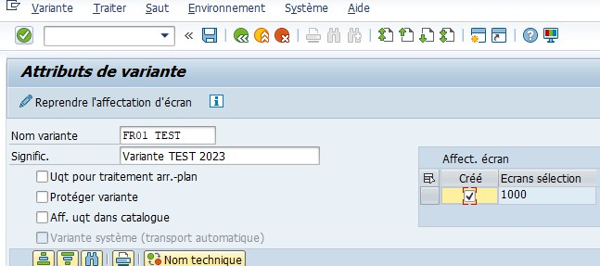

Then confirm:

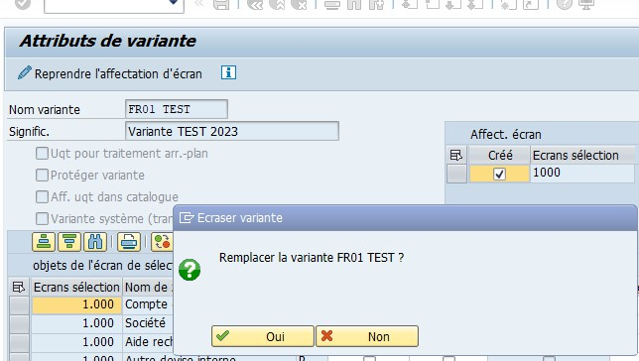

DELETE A VARIANT
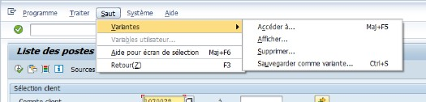

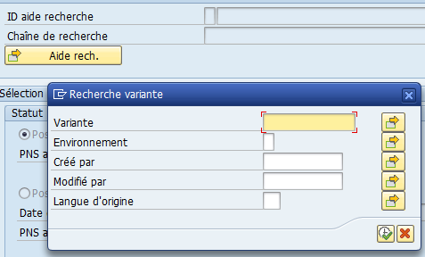

Search for the variant to be deleted:
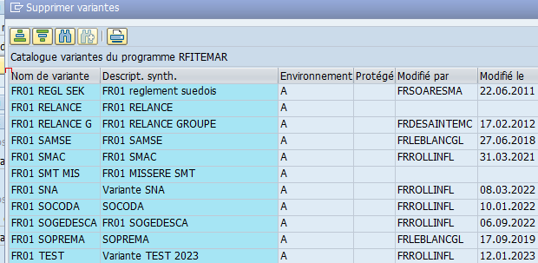
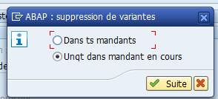
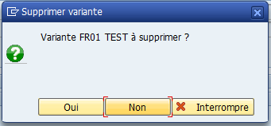

On: 03/11/2025
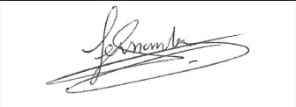
Procedure validated by : S. HERNANDEZ

